EX No:1b | EDA DATA CLEANING

AIM
To perform exploratory data analysis on the Diabetes Prediction Dataset by examining the dataset structure, dimensions, data types, statistical characteristics, missing values, gender-wise and smoking-history-wise diabetes distributions, age-wise diabetes patterns, blood glucose level analysis, BMI and HbA1c analysis, diabetes percentage calculation, correlation analysis, and exporting the cleaned dataset for further analysis.

ALGORITHM
- Import the required libraries such as Pandas, NumPy, and Matplotlib.
- Load the Diabetes Prediction Dataset into a Pandas DataFrame.
- Display the first five and last five records of the dataset.
- Display the dataset information, shape, column names, and data types.
- Generate descriptive statistical information for numerical attributes.
- Identify the number of missing values in each column.
- Remove blank rows and duplicate records from the dataset.
- Perform data cleaning and standardization on the required categorical and numerical attributes.
- Create an Age Group attribute by categorizing patients into Young, Middle Age, and Senior groups based on their age.
- Analyze the distribution of diabetes cases across different gender categories.
- Analyze the distribution of diabetes cases across different smoking-history categories.
- Analyze the relationship between age and blood glucose level and identify the variation in diabetes cases across different age groups.
- Calculate and analyze the Diabetes Percentage based on the total number of patient records.
- Calculate and analyze the correlation between numerical attributes such as Age, Hypertension, Heart Disease, BMI, HbA1c Level, Blood Glucose Level, and Diabetes.
- Export the cleaned dataset into CSV, Excel, and JSON formats and display a confirmation message after successful file creation.

CODE
import os
import pandas as pd
import numpy as np
import matplotlib.pyplot as plt

path = "diabetes_prediction_dataset.csv"

print("Dataset path:", path)

df = pd.read_csv(path)
Display First Five and Last Five Records
print("\nFirst 5 rows:")
display(df.head())

print("\nLast 5 rows:")
display(df.tail())
Display Dataset Information
print("\nDataset information:")
df.info()

print("\nShape:")
print(df.shape)

print("\nColumns:")
print(df.columns.tolist())

print("\nData types:")
print(df.dtypes)
Statistical Description
print("\nStatistical description:")
display(df.describe())
Missing Values
print("\nMissing values:")
display(df.isnull().sum())
Remove Blank Rows and Duplicate Records
df = df.dropna(how="all")

df = df.drop_duplicates()

print("\nDataset after removing blank rows and duplicates:")
print(df.shape)
Standardize Categorical Columns
df["gender"] = df["gender"].astype(str).str.strip().str.title()

df["smoking_history"] = (
df["smoking_history"]
.astype(str)
.str.strip()
.str.lower()
)

print("\nCategorical values after standardization:")

print("\nGender:")
print(df["gender"].unique())

print("\nSmoking History:")
print(df["smoking_history"].unique())
Create Age Group
df["Age_Group"] = pd.cut(
df["age"],
bins=[0, 29, 49, float("inf")],
labels=["Young", "Middle Age", "Senior"]
)

print("\nAge Group:")
display(
df[
["age", "Age_Group"]
].head()
)
Gender-wise Diabetes Analysis
print("\nGender-wise Diabetes Cases:")

display(
df.groupby("gender")["diabetes"]
.sum()
.sort_values(ascending=False)
)
Smoking History-wise Diabetes Analysis
print("\nSmoking History-wise Diabetes Cases:")

display(
df.groupby("smoking_history")["diabetes"]
.sum()
.sort_values(ascending=False)
)
Age Group-wise Diabetes Analysis
print("\nAge Group-wise Diabetes Cases:")

display(
df.groupby("Age_Group", observed=False)["diabetes"]
.sum()
.sort_values(ascending=False)
)
Blood Glucose Level Analysis
print("\nAverage Blood Glucose Level by Age Group:")

display(
df.groupby("Age_Group", observed=False)["blood_glucose_level"]
.mean()
)
Diabetes Percentage
diabetes_percentage = (
df["diabetes"].sum() /
len(df)
) * 100

print("\nDiabetes Percentage:")
print(round(diabetes_percentage, 2), "%")
Correlation Analysis
print("\nCorrelation:")

display(
df[
[
"age",
"hypertension",
"heart_disease",
"bmi",
"HbA1c_level",
"blood_glucose_level",
"diabetes"
]
].corr()
)
Export Cleaned Dataset
df.to_csv(
"Diabetes_Cleaned.csv",
index=False
)

df.to_excel(
"Diabetes_Cleaned.xlsx",
index=False
)

df.to_json(
"Diabetes_Cleaned.json",
orient="records",
indent=4
)

print("\nCSV, Excel and JSON files created successfully.")

OUTPUT
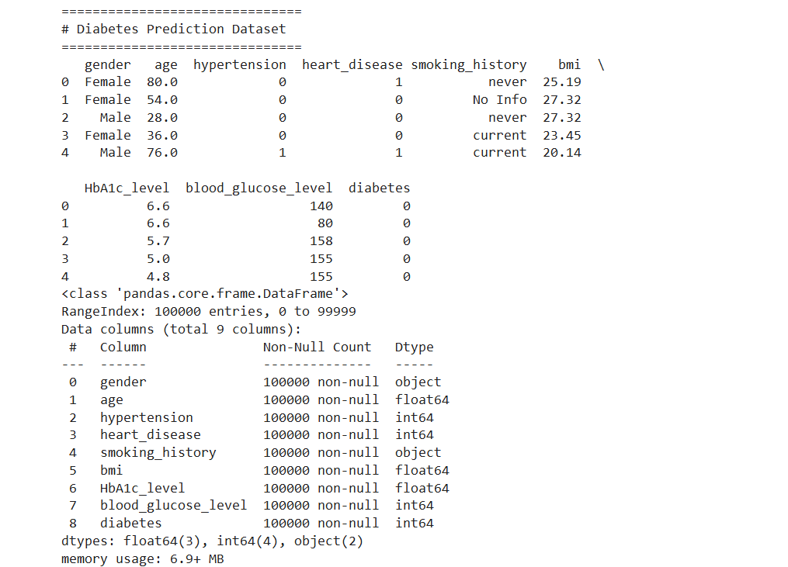
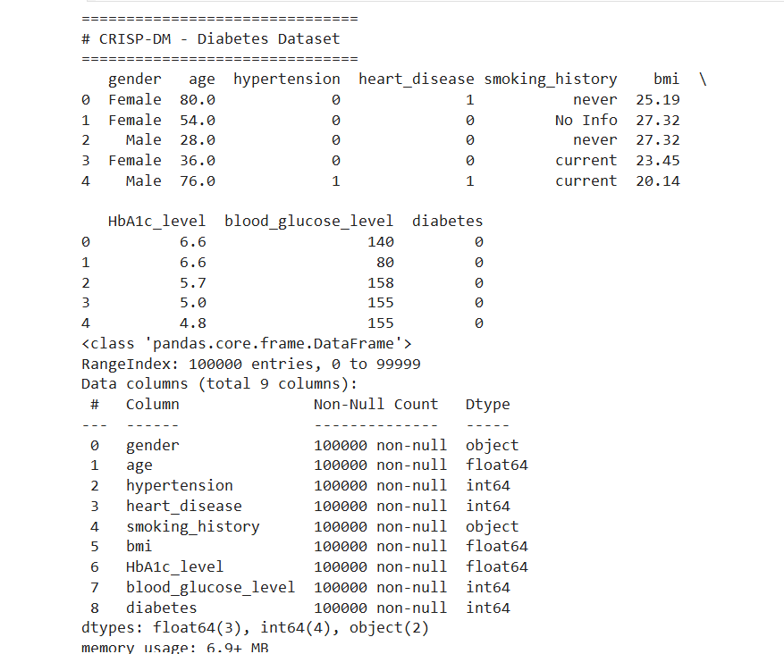
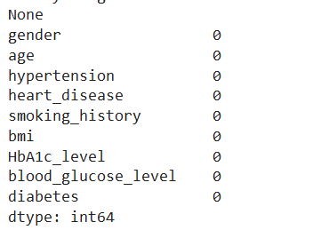

RESULT

